On the 23rd of February 2023 I was delighted to represent the Music Education Council at the Music and Drama Expo at the London Business Centre. I was chairing a panel about Equality, Diversity and Inclusion in the refreshed National Plan for Music Education (NPME) and MEC was there to put the spotlight on voices that are not usually heard in the sector. The panel included Sam Sikiru (Young Producer), Keith Sykes (Director of Community Music) and Tolu McCarthy (Music Educator).
The provocation discussed was: The national plan does not do enough to overhaul the way the sector views EDI. Urgent systemic change is needed to ensure that there is a unified understanding and sector wide commitments to EDI.
To begin the session we looked at the goals of the NPME:
1. All children and young people receive a high-quality music education in the early years and in schools
2. All music educators work in partnership, with children and young people’s needs and interests at their heart
3. All children and young people with musical interests and talents have the opportunity to progress, including professionally
We then went onto focus on EDI and it was clear from the word analysis in the NPME that ‘inclusion’ had many references yet ‘equity’, ‘equality’ and ‘diversity’ didn’t feature very much within the plan.
Our panel members then went on to discuss this relating to their personal experiences.
Sam talked about growing up and studying the arts and he highlighted that under-represented groups can be included for the wrong reasons. It is important that all children and young people are included because the policy makers want them there, it’s not just a tick box exercise. Sam made a plea to the policy makers to ensure that there is something in place where underrepresented groups of pupils don't feel like their experiences and achievements are void.
We then heard from Tolu who talked about her experience on a teacher training course. The course lecturer asked everybody what their musical backgrounds were and when Tolu spoke about singing in church and playing the keyboard the lecturer just looked at her and asked, “Oh, so do you read sheet music?” This is a valid question for a music course but it was interesting that he didn't ask anybody else, highlighting the need for systemic change within the sector. Tolu went on to explain that it's often down to the individual attitude of whoever is delivering your music education and you can have diversity plastered all over the NPME, but if the person delivering it doesn't see the importance, it might not have that much of an effect.
The discussion then went on with a focus on the curriculum. Sam stated that music is very important to a lot of children and young people. It’s relied upon and is something that is used every single day, but a lot of music teachers kill the passion of music. Five lessons in a row going through Beethoven's music without exploring other genres isn’t going to have a big impact, where as exploring different genres would more relevant and engaging.
Tolu then joined the conversation stating that it’s about balance and no one is saying do away with the Classical, Baroque, Romantic music, but there does need to be room for more modern genres to invite more children and young people to take a place at the table, and not feel isolated and ostracised because they don't know a certain symphony. Tolu’s plea was to simply have a more holistic approach of music.
We then heard from Keith and he felt that the biggest missing area in the NPME was around youth voice. There was no mention co-production with young people and it felt like a missed trick, because this is so central to equity, diversity and inclusion. Keith then went to highlight the gaps where young carers aren’t included and highlighted the need of equity of access for all young people to be more explicit. He stated that more details were needed in the NPME to support this.
The panel then went on to look at the IDEA framework (IDEA stands for Inclusion, Diversity, Equity and Access) and the IDEA project is facilitated by Youth Music and includes 8 music hubs (including Lewisham and Leicestershire) as part of the project. The aim of the IDEA project is to pilot a brand-new accreditation framework and this is currently being tested through a year of action research, learning, and peer support.
IDEA is broken down into eight ‘pillars’ of practice:
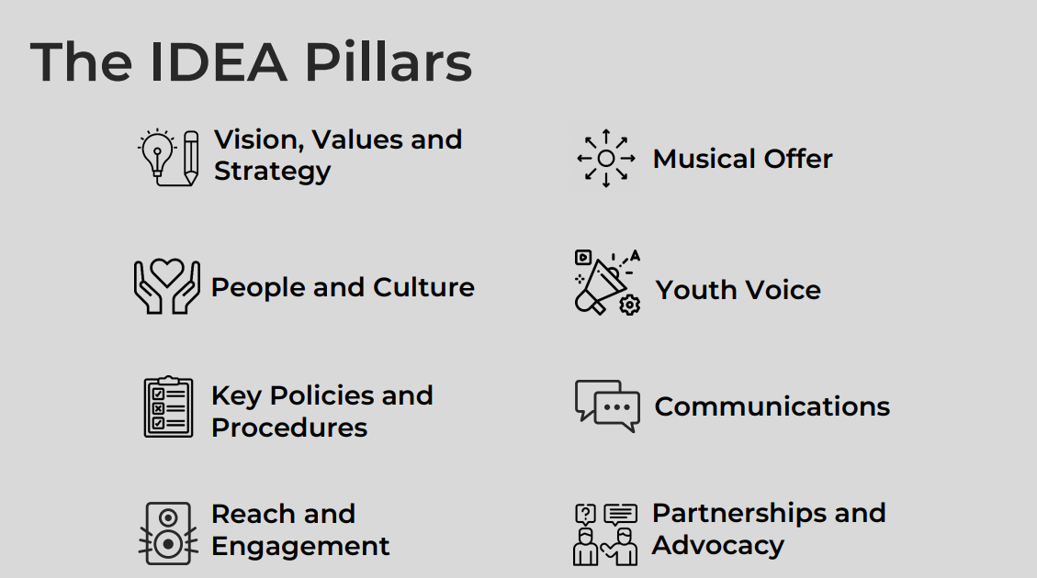
Keith went on the talk about how Lewisham Music has engaged with the project and how it has reinforced the policies that sat behind their work. Every Music Hub was on a different journey but this project has enabled Music hubs to focus on their individual journey and contribute to the National picture for EDI.

The panel then shared their call to Actions:

- Speak to another teacher /music hub / school leader about EDI
- When you are working with your YP, make a meaningful space for them – it’s not just a tick box exercise
- Take a risk –listen to your young people
- Policy makers –look at your polices, are they including underrepresented groups for the RIGHT reasons
- EDI is everyone's responsibility. Make ONE commitment to yourself and hold yourself accountable
- Follow the underrepresented voices on your socials, engage with them, champion them and challenge those who go against this
- Find out more about IDEA at www.youthmusic.org.uk/IDEA
After the session, the panel was approached by numerous people who attended the packed-out session in the Keynote Theatre. There were many messages of support and thanks for highlighting such an important issue. We were also asked where would be appearing next? Watch this space…!

Sharon Jagdev Powell MEC trustee and Interim Head of Leicestershire Music

