  Leicestershire  Music (LM)  Named  Safeguarding Staff and Contacts (April 2024) | Designated Safeguarding  (Lead DSL)  Sarah Barton-Wales  (Head of LM) sarah.barton@leics.gov.uk  Tel: 0116 3050400  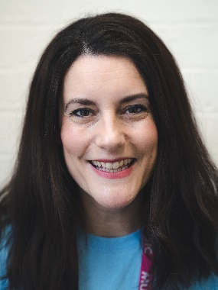 | Designated Safeguarding Lead:  (Deputy DSL)  Sharon Jagdev Powell  (Deputy Head of LM) sharon.jagdevpowell@leics.gov.uk  Mobile: 07936 349073   | Staff Allegations Lead  LM staff  Chris Bale  (Business Manager)  Chris.bale@leics.gov.uk    Tel: 0116 3050416
Deputy Designated  Safeguarding Lead:  Sarah Sharman  (Events Manager)  Sarah.sharman@leics.gov.uk    Tel: 0116 3050881 | Deputy Designated  Safeguarding Lead:  Rachel Thomas  (Central Bands & Orchestras Lead)  Rachel.X.Thomas@leics.gov.uk  Mobile: 07736 716092  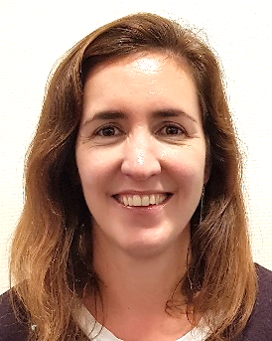 | Deputy Designated  Safeguarding Lead:  Nicola Atkins  (Singing Team Leader)  Nicola.Atkins@leics.gov.uk  Tel: 0116 3051652  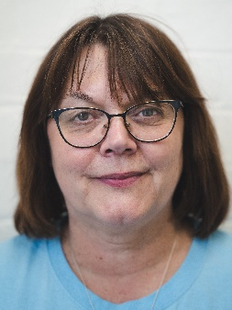 | Deputy Designated  Safeguarding Lead:  Craig Thurlow  (Music Leader)  Craig.Thurlow@leics.gov.uk  Tel: 0116 3051657  

