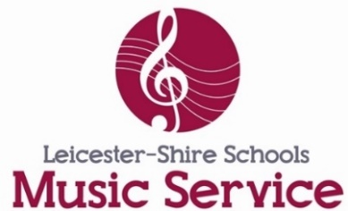
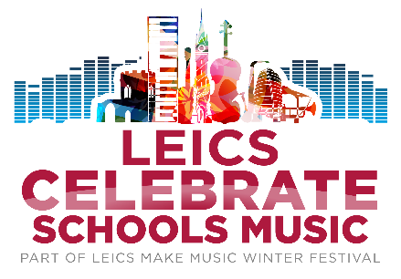

Leics Celebrate Schools Music – Consent Form

Please upload completed form along with your performance video,
saving both uploads as your school name

SCHOOL INFORMATION

Name of school:

Name of person submitting performance:

Email of person submitting performance:

Contact telephone number of school:

GENERAL INFORMATION ENSEMBLE RECORDING

Name of performance group:

Number of participants:

Year group:

Type of ensemble:

Name of piece:

Background information: Please provide us with a bit of background information about your performance, does this piece have a special meaning to your school? What circumstances was it recorded in? How long have the children been learning their instruments? Information you provide here may be used on screen during your performance to tell viewers about your choir.

IF SUBMITTING SOLO PERFORMANCES ON BEHALF OF PUPILS

Name of performer:

Instrument:

Year group:

How long have they been learning their instrument?:
Background information: Please provide us with a bit of background information about your performance, does this piece have a special meaning to you? What do you love about playing your instrument? Information you provide here may be used on screen during your performance to tell viewers about your choir.

CONSENT FOR USE OF PHOTOGRAPHY/AUDIO/VIDEO FOOTAGE

I agree to allow our video recording to be used by LSMS in the online Leics Celebrate Schools Music Event on YouTube

I give permission for our school name to be published/tagged along with their submission, including online and in social media

I give consent for the use of the material in: - Print publications - Press use (newspapers & periodicals) - Web/Social Media use - Evaluation Purposes

I agree to notify Leicester-Shire Schools Music Service before speaking to the press/broadcast media concerning this project.

For further information on our privacy notice please visit https://leicestershiremusichub.org/privacy

DECLARATION
Having read the information provided, I agree to (name of school) …………………………………………taking part.

I declare that I have permission from all performers in the video to share this performance in the public domain.
I agree that photography and video/audio footage of the project may be used as outlined above.

In giving permission to use this video, (name of school) ……………………………………………… ensure that parents and carers of any children featured in this video have consented to be filmed and for the film to be shared.

I understand that submitting this video does not guarantee inclusion in Leics Celebrate Schools Music and that the video may be edited to show highlights, due to time constraints.

Full name of choir member (please PRINT CLEARLY)
Name:

Signed:

Date:

EXPLANATORY NOTES
This form serves several important functions.
1. It confirms your knowledge of and your agreement to your (choir’s) participation in the event on the terms outlined in the accompanying information.
2. Data Protection. The data collected by us will fulfil its data protection obligations by treating all personal data, held manually and on computerised administrative systems, with due care and confidentiality. Personal data will only be disclosed in accordance with the Data Protection Act 1998.

How to upload your video and consent form
Please save your video and consent from as the name of your school and upload to:
https://www.dropbox.com/request/Leicscelebrateschools

For queries please contact: lsms@leics.gov.uk Subject: Leics Celebrate Schools Music submission query

