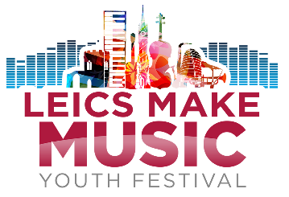
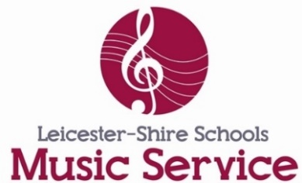

Leics Make Music Online Festival 2020 – Young People’s Consent Form

Please upload completed form along with your performance video, saving both uploads as your name

NB. If you are a band with members from more than one family then you will need a parental consent form for each band member.

GENERAL INFORMATION

Name of participant:

Date of birth:

School/College:

Name of band / act / performer name:

Background information: Please provide us with a bit of background information about your performance, does this piece have a special meaning to you, what circumstances was it recorded in, what does it mean to you to perform at the festival?

PARENT / CARER INFORMATION

Name of parent/carer:

Relationship to participant:

Contact telephone number:

Contact email address:

Home address of participant:

CONSENT FOR USE OF PHOTOGRAPHY/AUDIO/VIDEO FOOTAGE

By allowing my child to participate in the festival I agree to allow my child’s submission to be used by LSMS in the online festival on YouTube

I give permission for my child’s name to be published/tagged along with their submission, including online and in social media

I give consent for the use of the material in: - Print publications - Press use (newspapers & periodicals) - Web/Social Media use - Evaluation Purposes

I agree to notify Leicester-Shire Schools Music Service before speaking to the press/broadcast media concerning this project.

For further information on our privacy notice please visit https://leicestershiremusichub.org/privacy

DECLARATION
Having read the information provided, I agree to (my child) taking part.
I agree that photography and video/audio footage of the project featuring my child may be used as outlined above.

I understand that submitting this video does not guarantee inclusion in the festival.

Full name of parent/carer
(please PRINT CLEARLY)
Name:

Signed:

Date:

EXPLANATORY NOTES
This form serves several important functions.
1. It confirms your knowledge of and your agreement to your (child’s) participation in the event on the terms outlined in the accompanying information.
2. Data Protection. The data collected by us will fulfil its data protection obligations by treating all personal data, held manually and on computerised administrative systems, with due care and confidentiality. Personal data will only be disclosed in accordance with the Data Protection Act 1998.

For queries please contact: lsms@leics.gov.uk subject: Leics Make Music submission query

