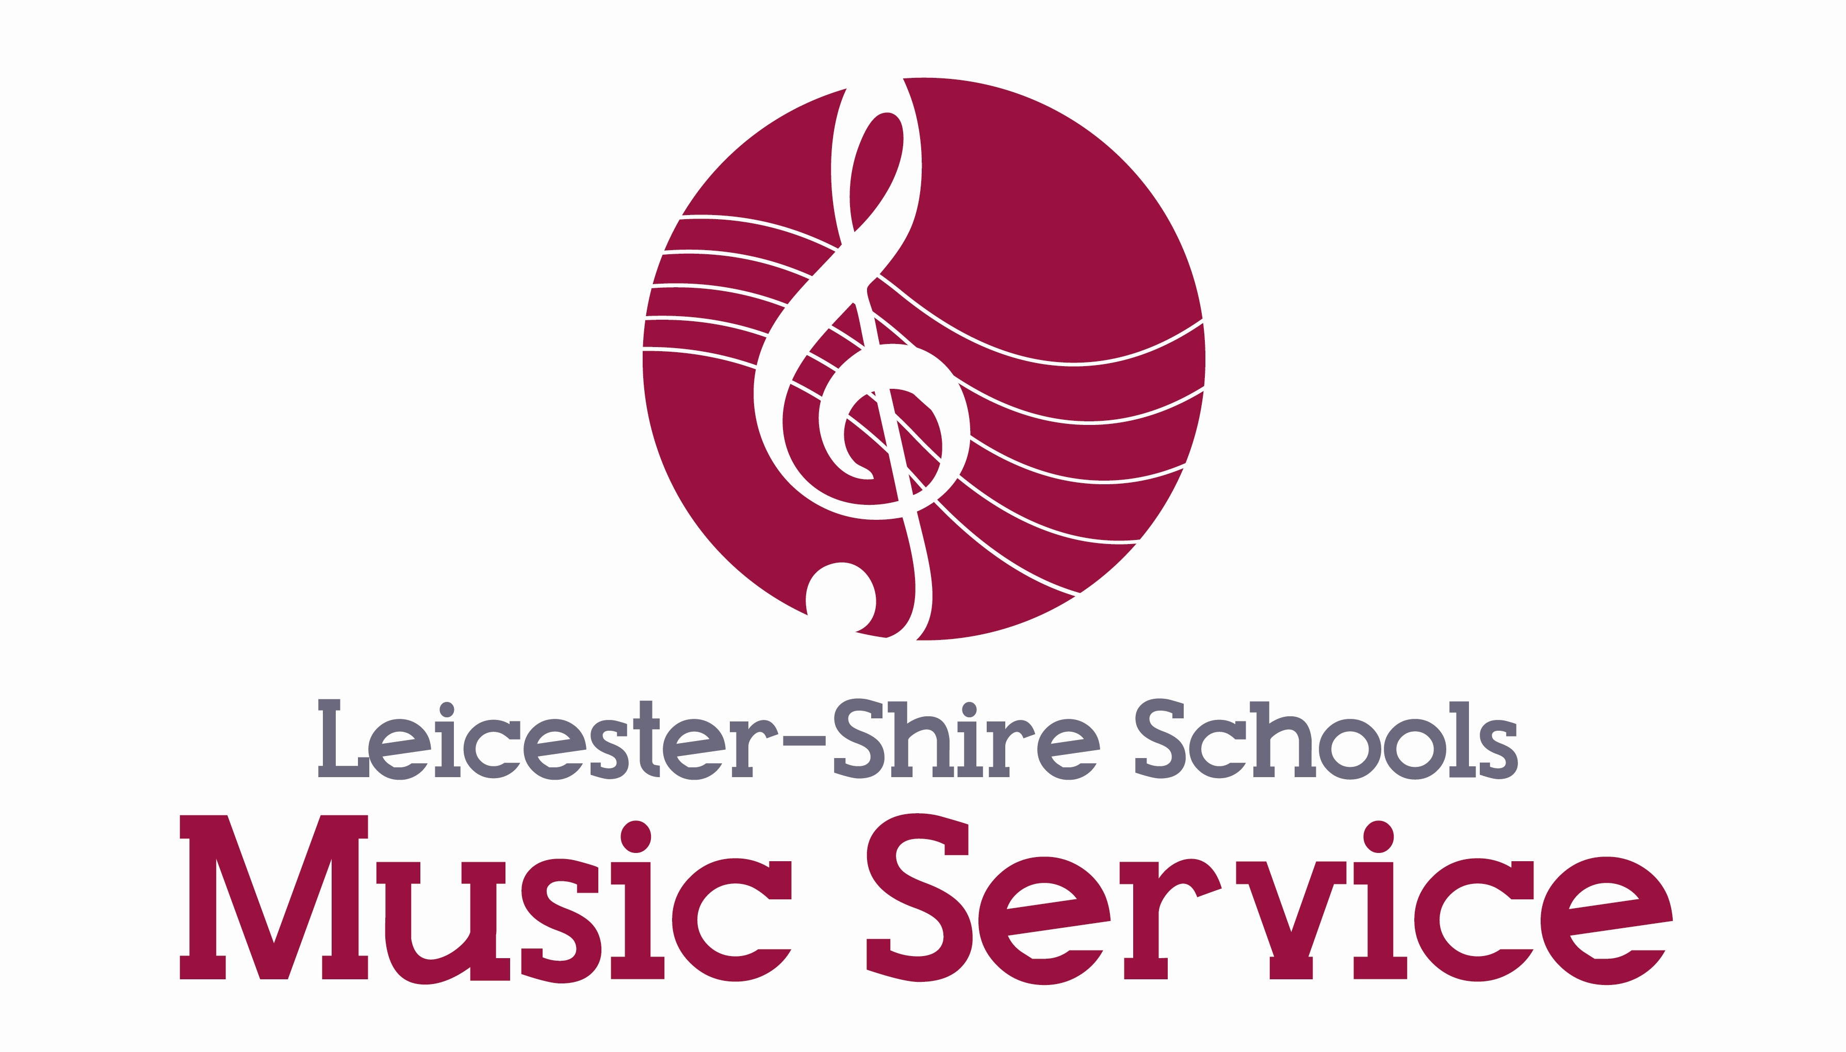

Are you aged 14 – 19?

Do you like to sing?

Want to take your singing to the next level?
Why not come and join our County choir?

- Do I have to audition?

No, there are no auditions for the choir. You just have to enjoy singing and be committed to rehearsals.

There may be some solo parts and there might be an audition for these parts if you wanted to be considered. Ideally we would like you to be recommended by someone (your music or singing teacher for example) – but this is not essential.

- What sort of music will we sing?

We will sing a bit of everything – so there should be something that will suit you and it will give you the chance to get to know some new styles of music.

- When will we practise?
We will rehearse weekly on Thursday evenings at The Samworth Enterprise Academy, Trenant Road, Leicester LE2 6UA from 6.45 – 8.15pm.
- How much does it cost?

We are currently offering the Autumn Term FREE OF CHARGE!* This is a unique special offer as we are looking to build a successful large choir and would like as many new members as possible.

- Sounds great! How do I get started?

Come along on a Thursday evening and meet David Bray, our new choir conductor and try the choir out! To sign up please complete the attached form and return it by Friday 18th October 2013 and we will be in touch with dates of the first rehearsal.

.
Youth Choir Registration Form

I wish to try the LSMS Youth Choir.

Your name: ____________________________________

Address: ________________________________________________________________________________________________________________________________________________________________________________________________________

Telephone: _____________________________________

Email: _________________________________________

Voice part (if known) soprano/alto/tenor/bass (delete as appropriate)

Have you had any experience of singing?
______________________________________________________________________________________________________________________________________________________________________________________________________________________________________________________________________________________________________________________________________________

Would you like to be considered for a solo part? Y/N (delete as appropriate)

Recommendation from? (for example your music teacher or singing teacher):
_____________________________________________________________________________________________________________________________________

Please return this form by Friday 18th October 2013 to:

Sarah Barton
Singing Development Leader
Leicestershire Schools Music Service
Abington House
85 Station Road
Wigston, Leicestershire
LE18 2DP

Any queries please contact sarah.barton@leics.gov.uk






*Usual fees for the choir are £44 per term. Full Fee Remission is available in line with Free School Meals – for more information please contact us at lsms@leics.gov.uk

