How to Register a student for an LSMS Performance Group

- In your Internet Browser, visit the following address https://live.paritor.com/p/3

- Click on ‘Register’ which will take you to the ‘Register’ Screen. (When revisiting the site, please click on Log On – you will need to do this rather than entering your details and pressing Return).

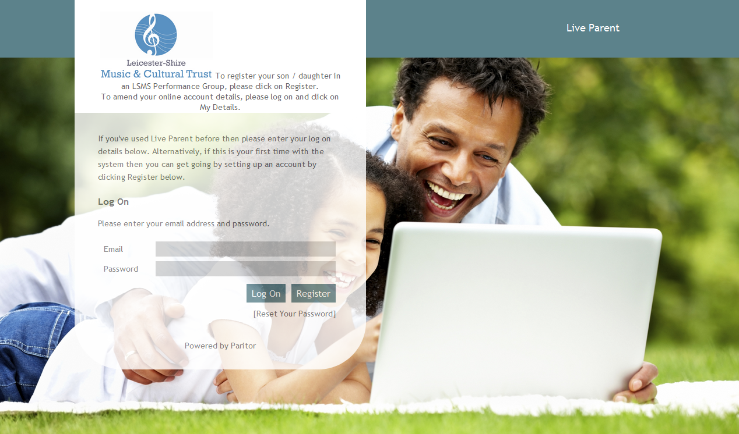

Here is the ‘Register’ screen

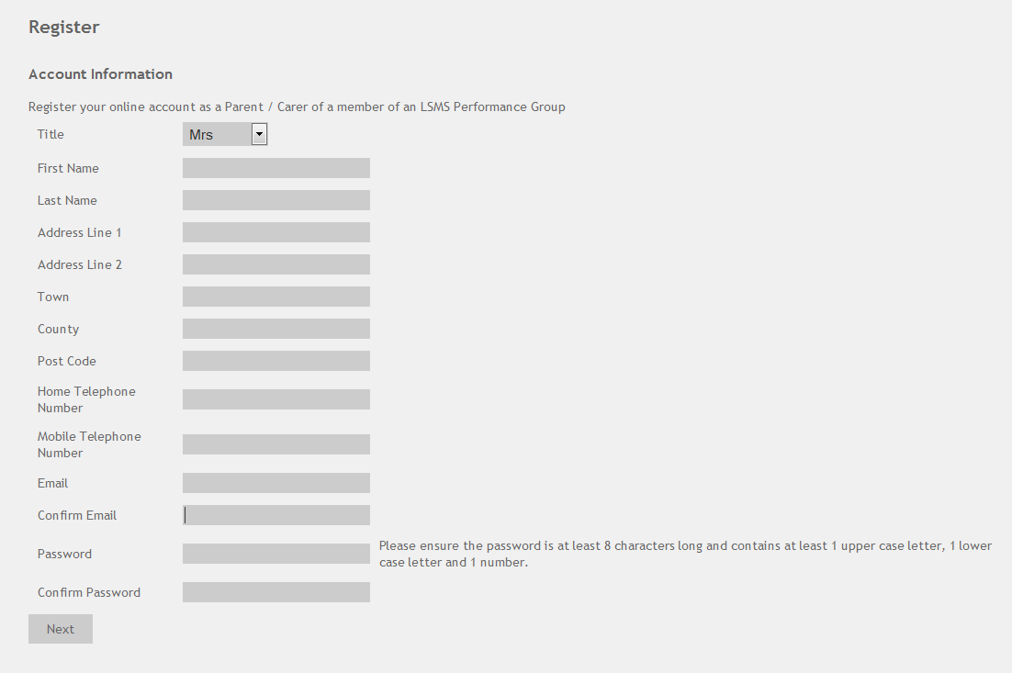

- Please complete all fields and click on ‘Next’ – (You will have the option of adding a second Parent / Carer later if required).

Please select ‘Enrol for an Activity’ to begin the registration of your son / daughter.

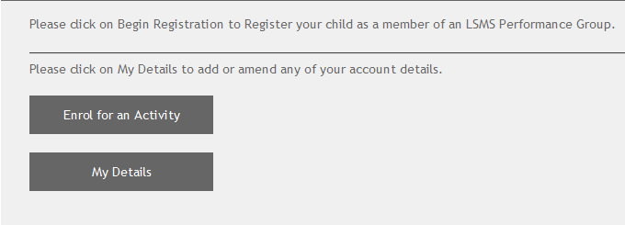

Step One - Please select the required LSMS Performance Group from the drop down menu.

If your child will be using the Saturday transport / Bus, please register them as being a member of the Bus Group, in addition whichever group/s they have been offered a place in.

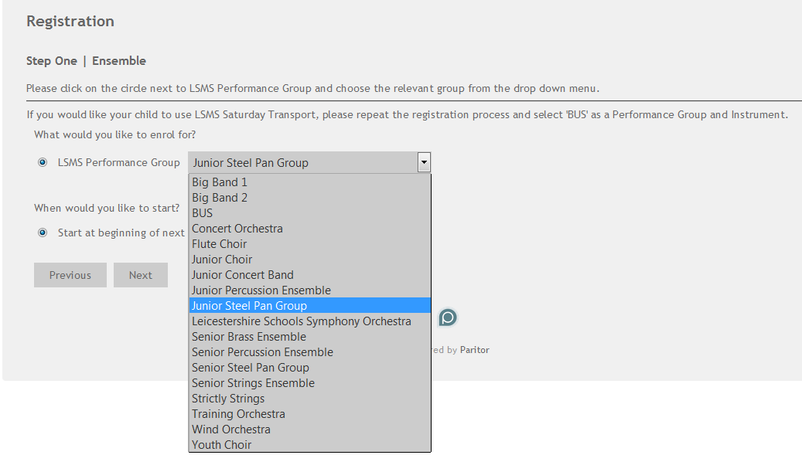

Then click on ‘Next’.

Step Two – Please select the instrument played by the child you are registering from the drop down menu, then enter the relevant Grade level. If no grades have been taken, please enter ‘N/A’.
Then click on ‘Next’.

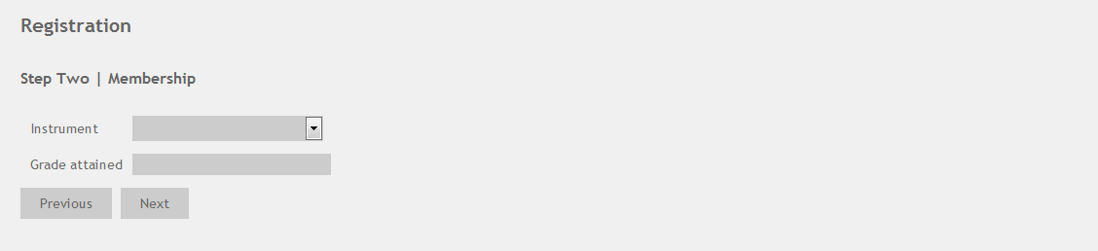

Step Three – Please complete the student details using the fields shown. The Address fields will automatically be populated with the information entered when setting up your account as a Parent / Carer (for test reasons I entered Abington House here but your own address should be shown.) This can be changed if the student lives at a different address.
Then click on ‘Next’.

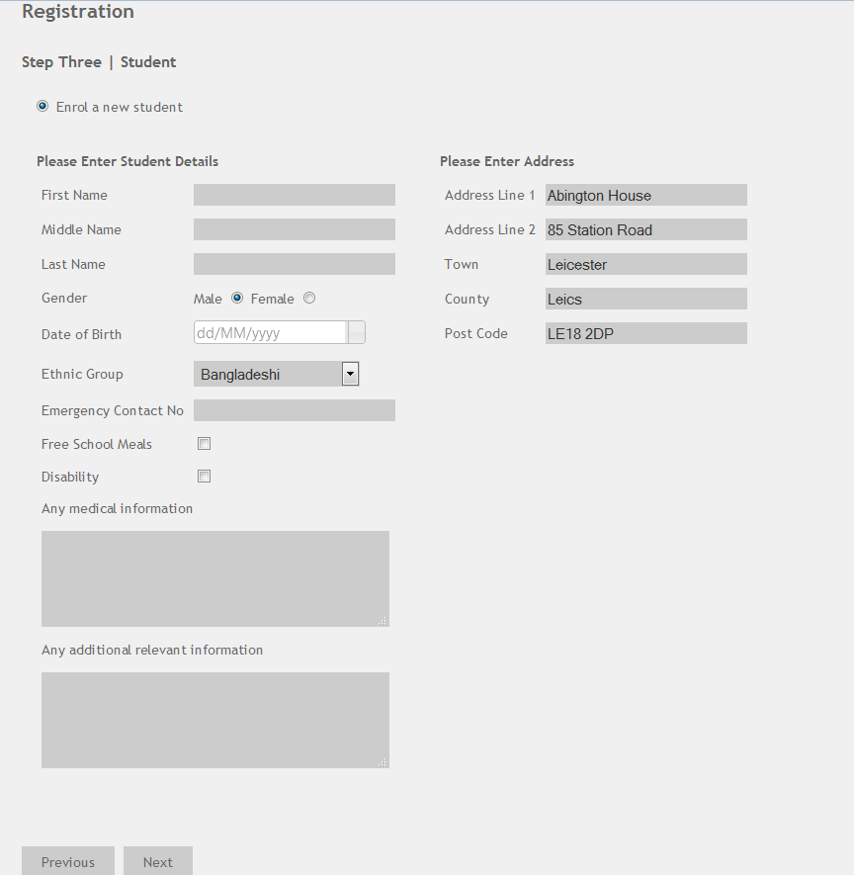

Step Four
If you only require one set of Parent / Carer details, please select your relationship to the student from the drop down menu shown.
Then click on ‘Next’.

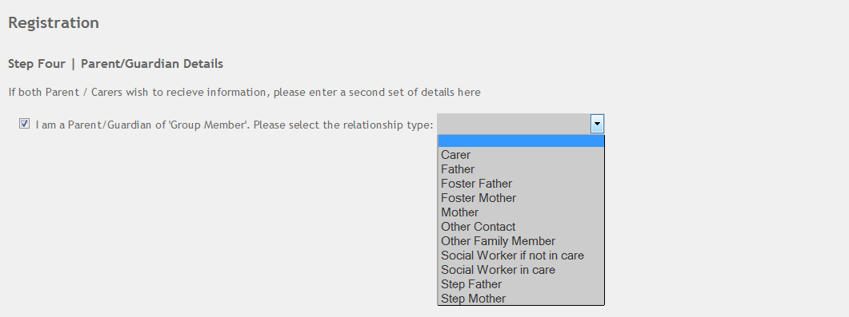
If you need to add a second set of Parent / Carer details, please untick the box and enter the details in the fields shown. Then click on ‘Next’.

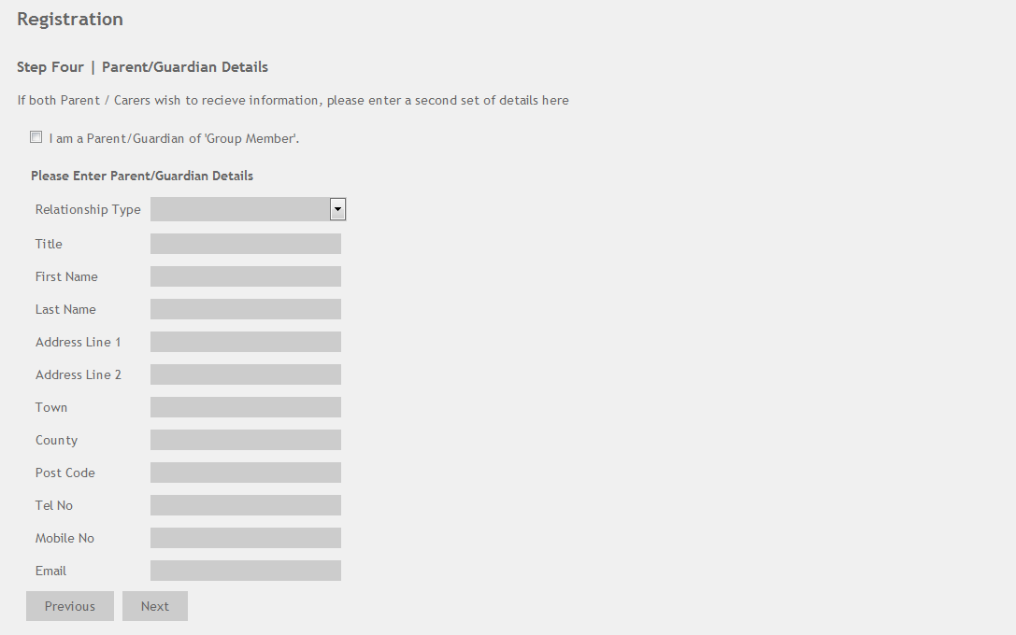

Step Five – Payment
This screen allows Parent / Carers to notify LSMS if they are eligible for fee remission. There are two types available.
The Endangered Orchestral Instruments Scheme and receipt of Government Support or Credit
ENDANGERED ORCHESTRAL INSTRUMENTS SCHEME 2015/16
Trombone, French Horn, Tuba, Viola, Double Bass, Oboe and Bassoon are all vital instruments in our central performance groups and players of all these ‘Endangered Orchestral Instruments’ are in short supply. LSMS will offer NEW STUDENTS a subsidised place on the above instruments in our ensembles. Eligible students for this scheme will have their first terms’ membership FREE and a remission of 50% on remaining terms membership for the academic year 2015/16. These discounts apply to Performance group membership only and will not, where applicable, apply to charges for Saturday transport. NB - This offer is only open to students who are new to LSMS Performance Groups and have not been members previously.

If you are in receipt of any of the following, you will be eligible for full remission of fees
Income Support or Pension Credit (Guarantee element) - (A recent letter from the Department for Work and Pensions to show your entitlement).

Income Based Job Seekers Allowance - (A copy of your letter from the Department for Work and Pensions or your local Job Centre (all pages confirming your entitlement).

Child Tax Credit (if their income is less than £16,190 per year. and whether or not in receipt of Working Tax Credit) (Please provide Form TC602 from the HM Revenue and Pensions (all pages) which confirms your entitlement to Child Tax Credit)

Support under the Asylum and Immigration Act. (Please provide documents from the National Asylum Seekers Support Service to prove that you are receiving support as an Asylum Seeker).

If you are eligible for either kind of remission, please tick the box shown and choose the relevant remission. If you are not eligible, please leave the box unticked.
Then click on ‘Next’.
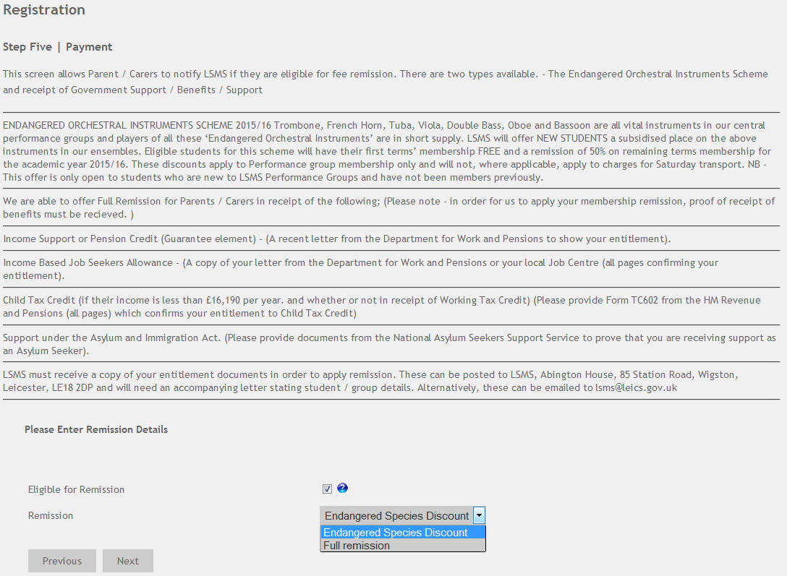

If you accept the Privacy statement, please click on ‘Next’. If not, please untick the box and click on ‘Next’.

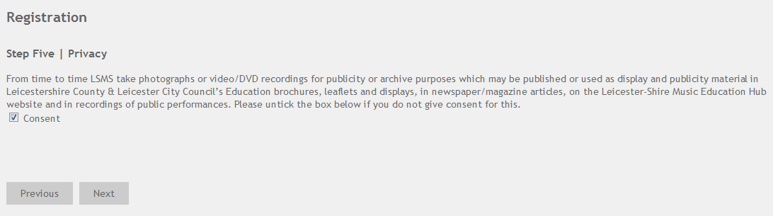

Step Six – The Checkout screen will show the membership information and fee for the student you have just registered.

If you wish to register another student, or the same student in another group, please click on ‘Add Another Pupil’ and follow the registration steps again. The system should remember any details you added previously (address, emergency contact number etc) so you shouldn’t need to type out all of your details again.

If your child will be using the Saturday transport, please register them as being a member of the Bus Group, in addition whichever group they have been offered a place in.

Please ignore the ‘Hire Details’ tick box – this is currently not in use and will be removed shortly.

NB – clicking on ‘Remove’ will delete the relevant registration details.

In order to complete the registration, you will need to tick the box marked ‘I agree to the terms and conditions’ – these can be seen by clicking on the text – this will link to a page on our website where you can access the terms and conditions.

If the information is correct please click on ‘Enrol’

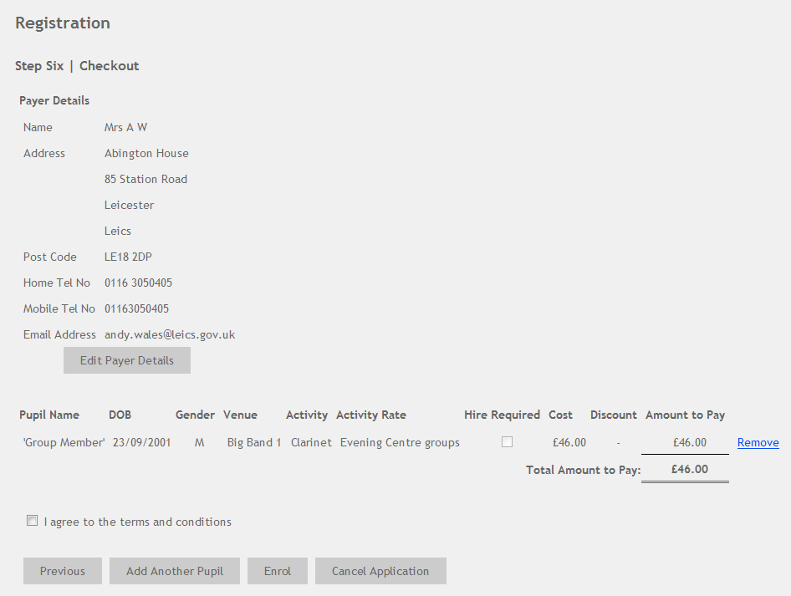

You should now have successfully registered your child / children for LSMS Group Membership and should see this screen next. You can now click on ‘Logout’– in the top right hand corner, or ‘Return’, which should take you to the LSMS / LMEH website.



